Algorithms Booklet

AQA 2018

Q 1
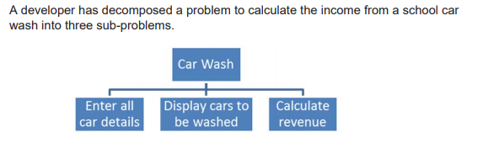
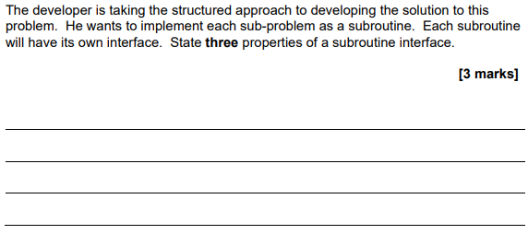
Q 1.1
Q 1.2

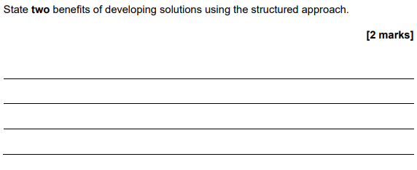

Q 1.3

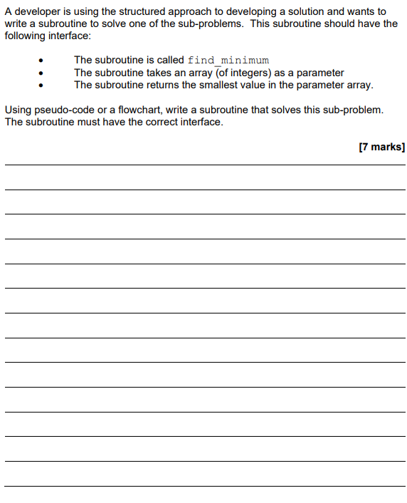

Q 2

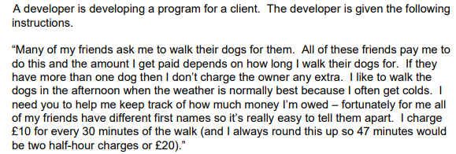

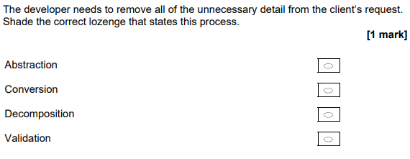
Q 2.1
Q 3
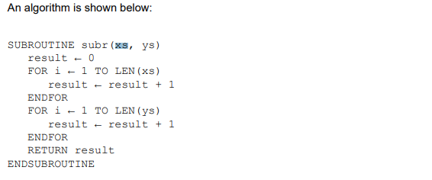

Q 3.1

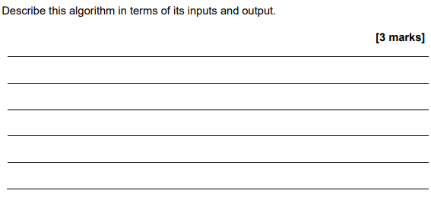

Q 3.2

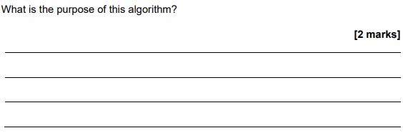

Q 3.3

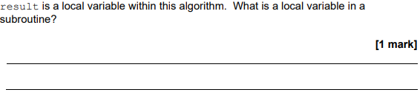

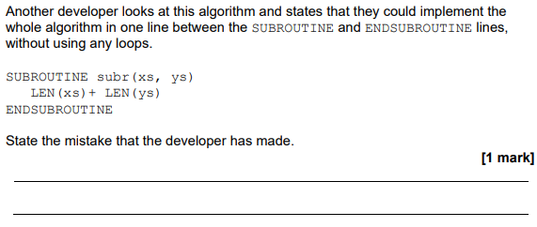
Q 3.4

Q 3.5

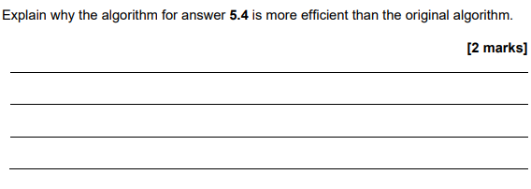
Q 4.1

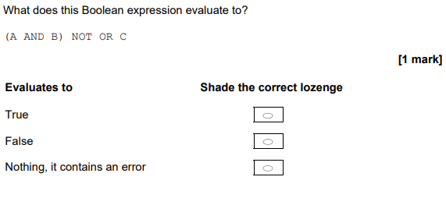
Q 4.2

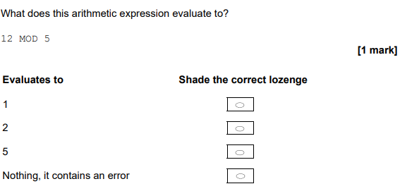

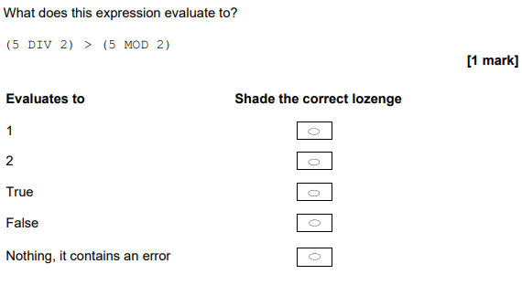
Q 4.3

Q 5.1
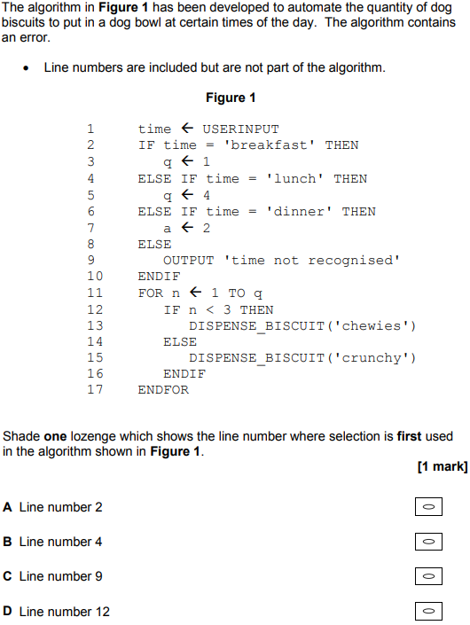

Q 5.2
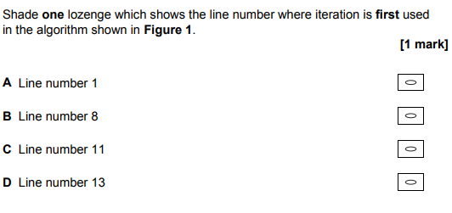

Q 5.3
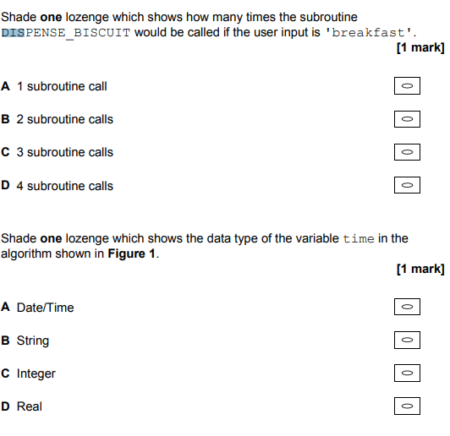

Q 5.4

Q 5.5

Q 5.6

Q 5.7

Q 5.8
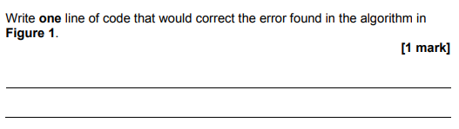

Q 6

Q 7.1

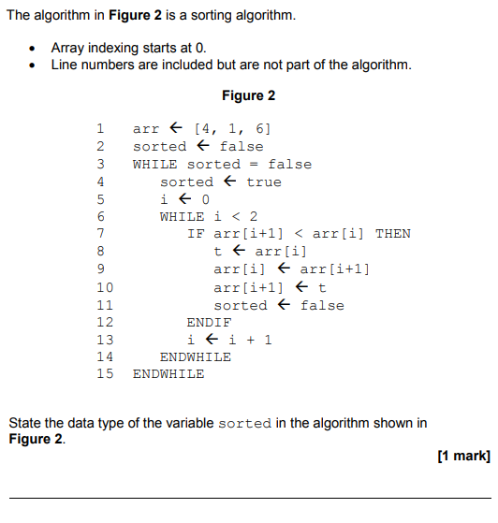

Q 7.2
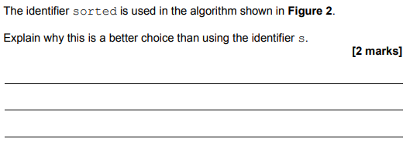

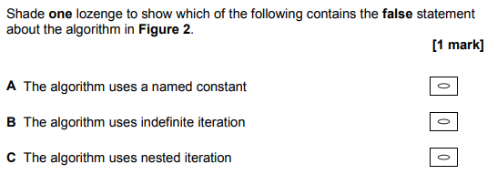
Q 7.3

Q 8
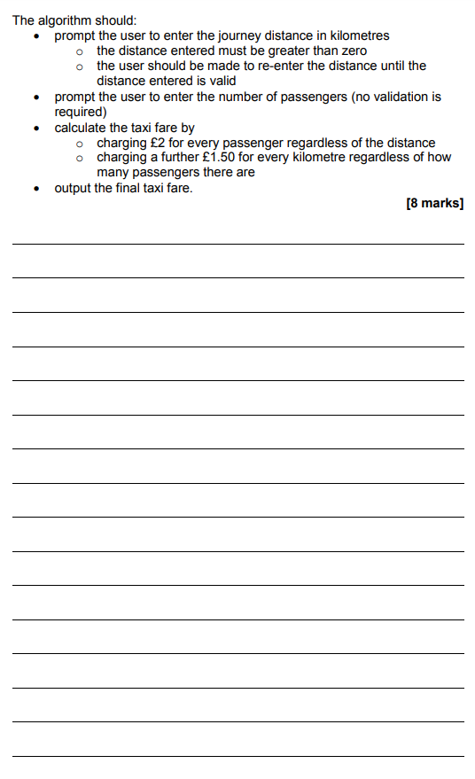

Q 9.1
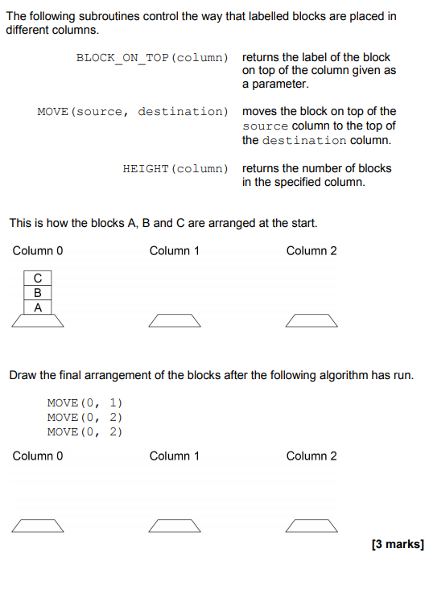

Q 9.2
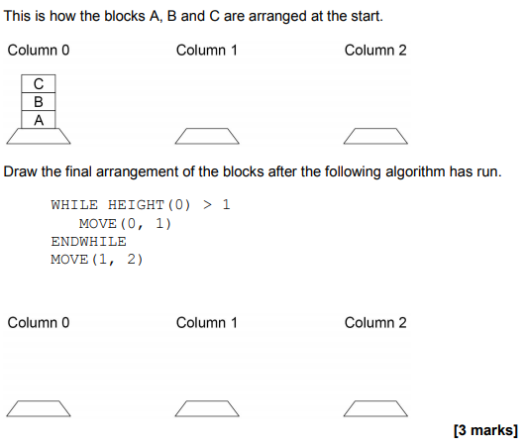

Q 9.3.
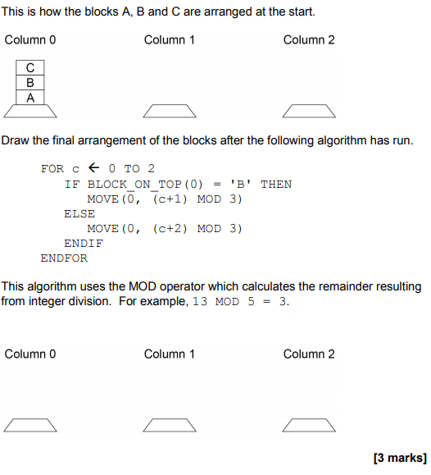

Q 9.4
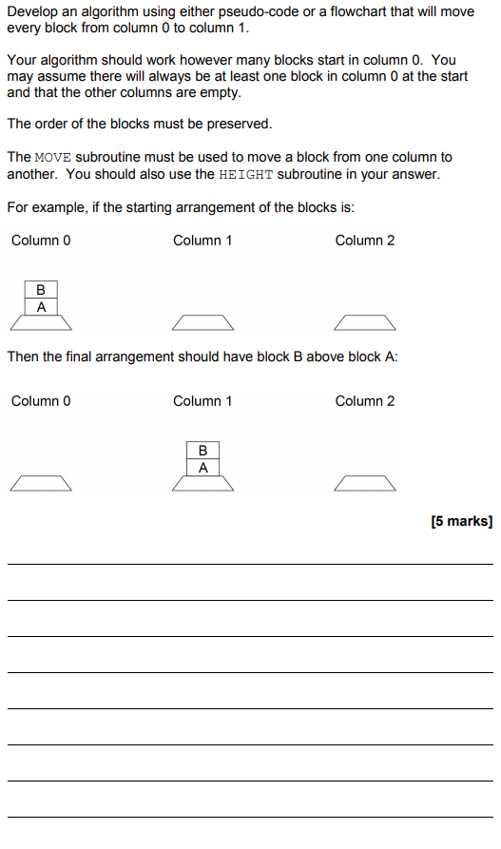

Q 10
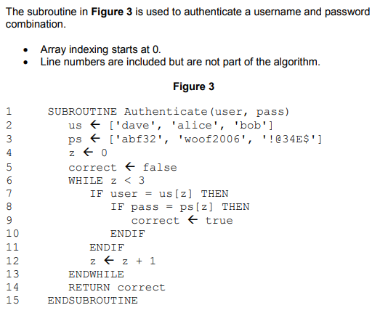

Q 10.1
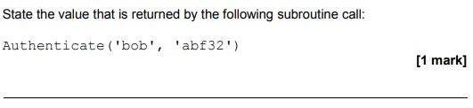

Q 10.2

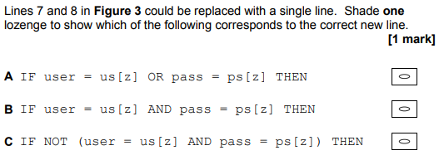

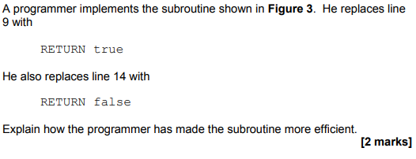
Q 10.3

………………………………………………………………………
………………………………………………………………………
………………………………………………………………………
………………………………………………………………………

Q 11.1

Q 11.2
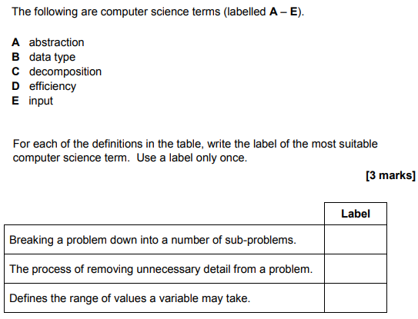

Q 12

AQA 2020: AQA New Spec
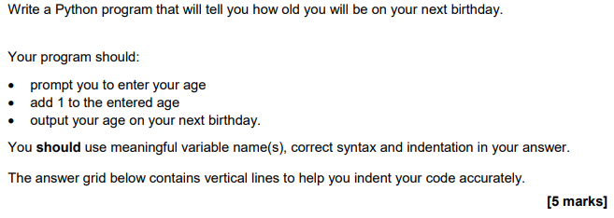
……………………………………………………………………………………………………………………………………………………………………………………………………………………………………………………………………………………………………………………………………………………………………………………………………………………………………………………………………………………………………………………………………………………………………………………………………………………

Q 13

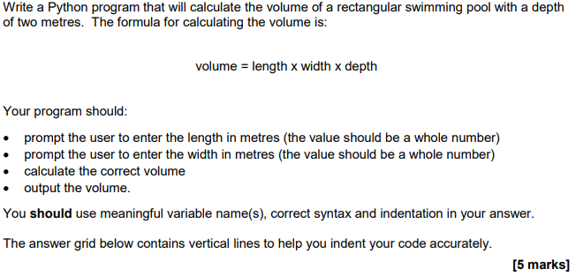
………………………………………………………………………………………………………………………………………………………………………………………………………………………………………………………………………………………………………………………………………………………………………………………………………………………………………………………………………………………………………………………………………………………………………………………………………………………………………………………………………………………………………………………………………………………………………………………………

Q 14
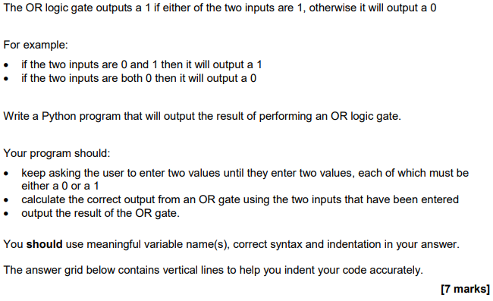
…………………………………………………………………………………………………………………………………………………………………………………………………………………………………………………………………………………………………………………………………………………………………………………………………………………………………………………………………………………………………………………………………………………………………………………………………………………………………………………………………………………………………………………………………………………………………………………………………………………………………………………………………………………………………………………………………………………………………………………………………………………………………………………………………………………………………………………………………………………………………………………………………………………………………………………………………………………………………………………………………………………………………………………………………………………………………………………………………………………………………………………………………………………………………………………………………………………………………………………………………………………………………………………………………………………………………………………………………………………………………………………………………………………………………………………………………………………………………………………………………………………………………………

Q 15

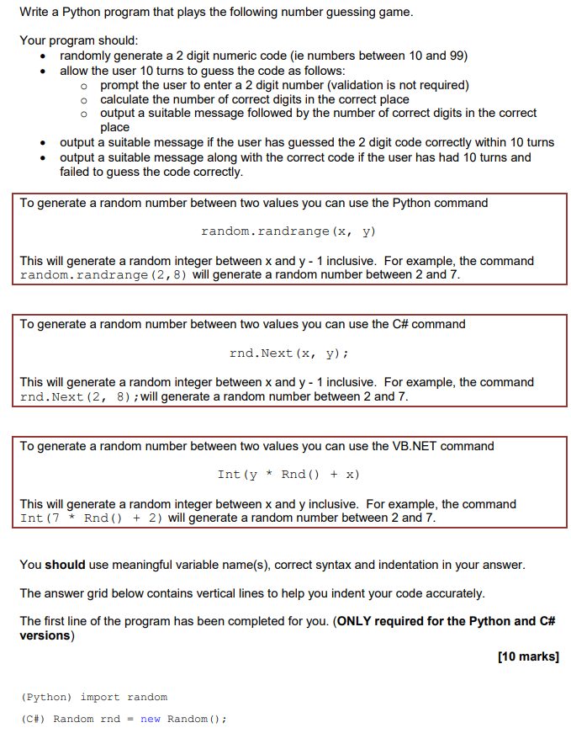

Q 16

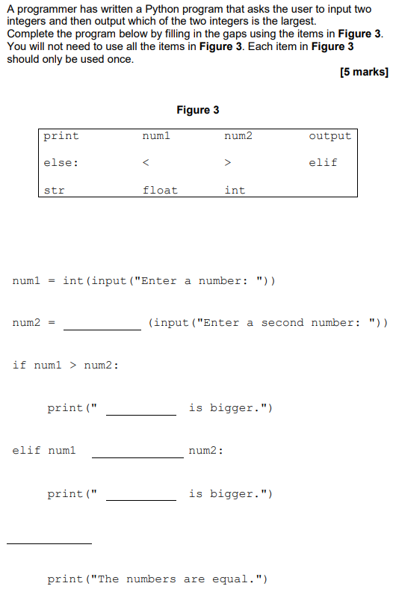

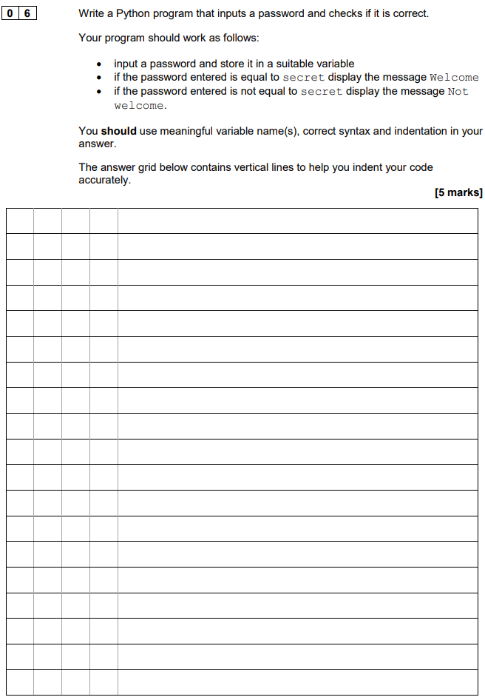
Q 17

Q 18

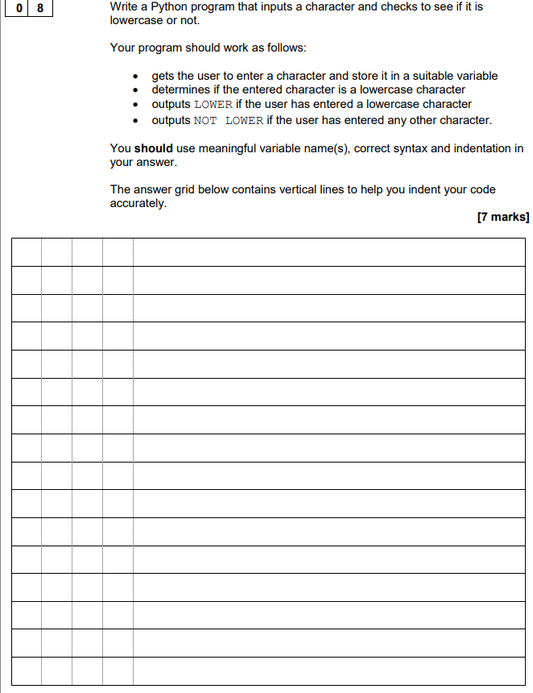

Q 19
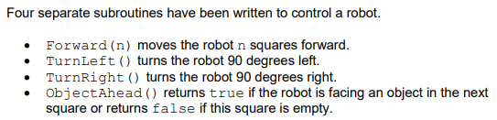

Q 19.1
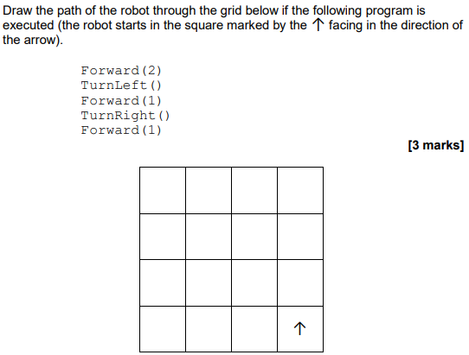

Q 19.2

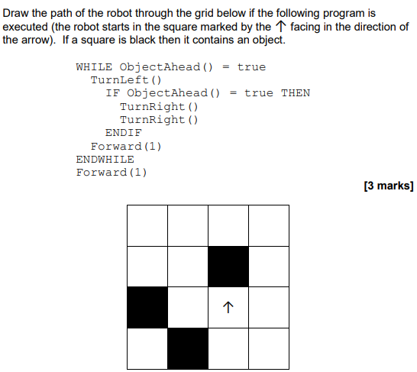

Q 19.3

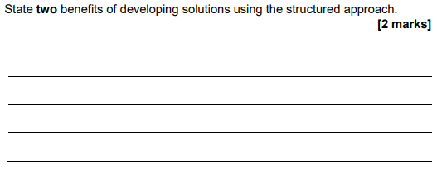

Q 19.4

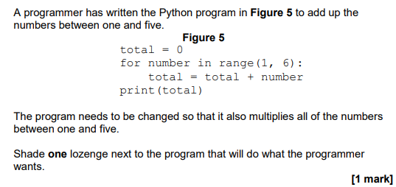

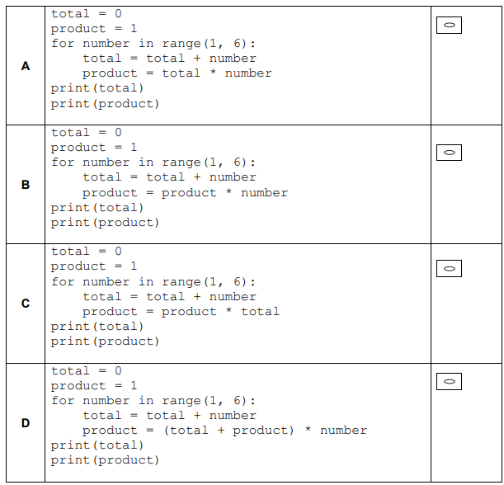

OCR GCSE Spec
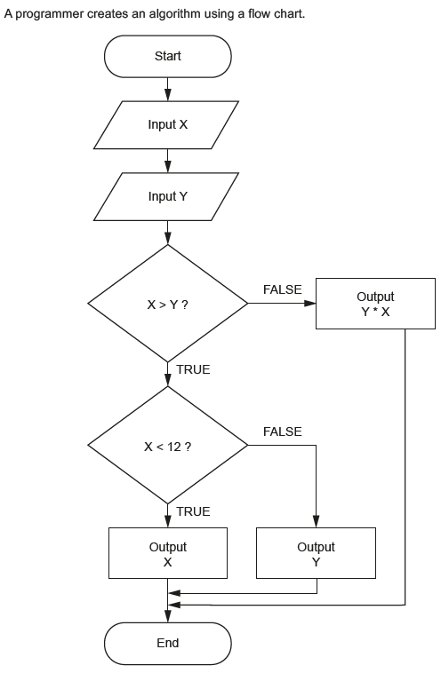
Q 20

Q 20.1

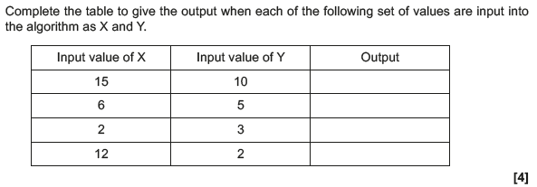
Q 20.2

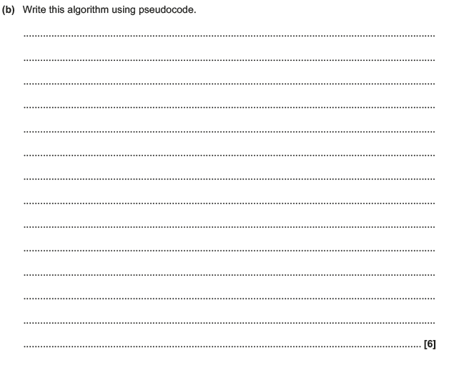
Q 21

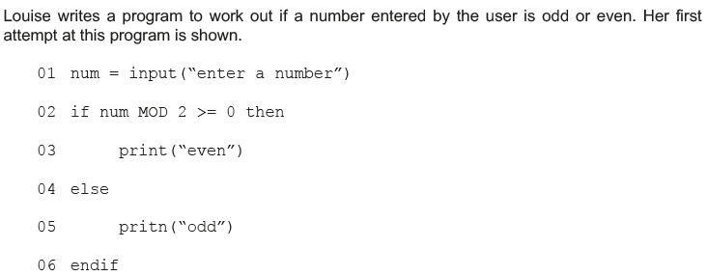
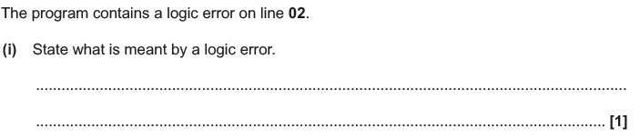
Q 21.1
Q 21.2

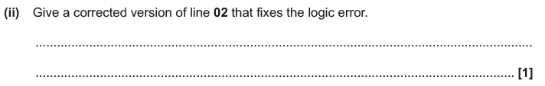
Q 21.3

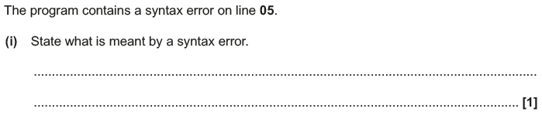
Q 21.4
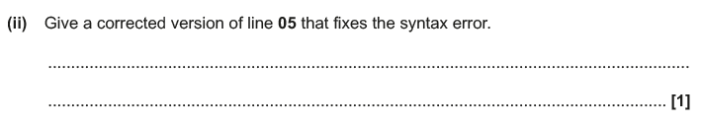
Q 22

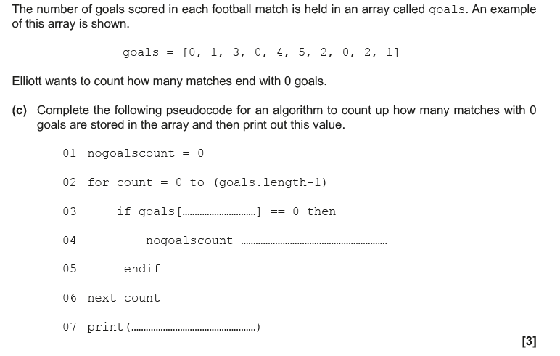

Q 23.1

Q 23.2

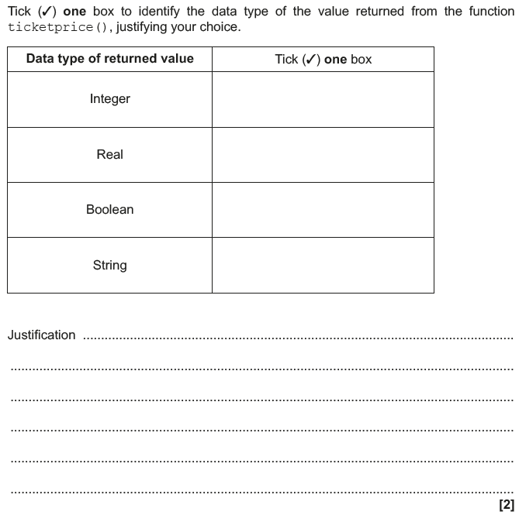

Q 24

Q 25

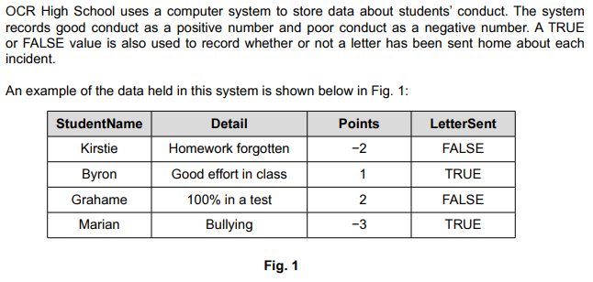
Q 25.1

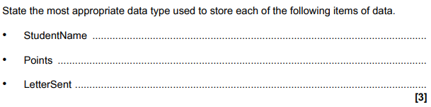
Q 25.2

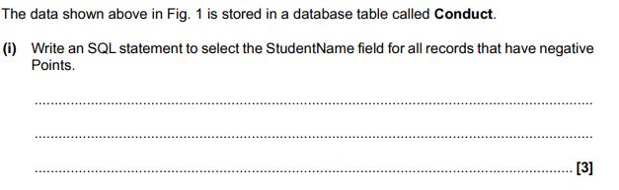
Q 25.3

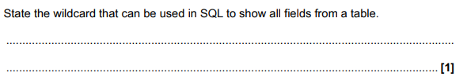

Q 25.4

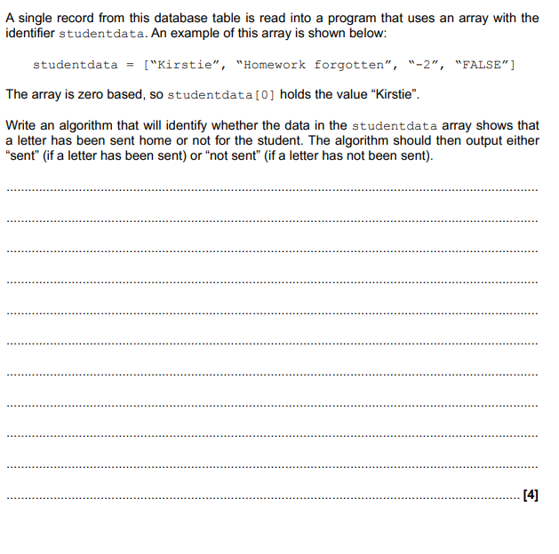

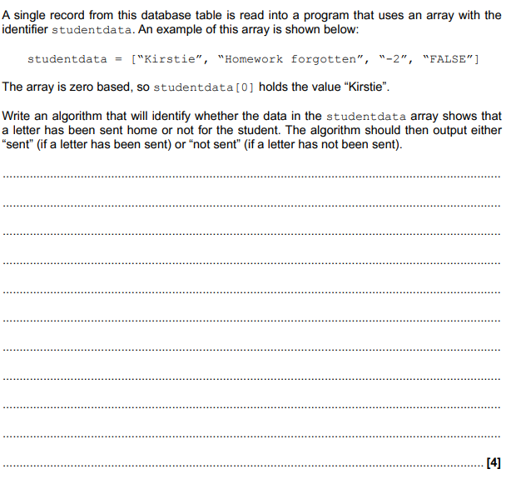
Q 25.5
Q 26
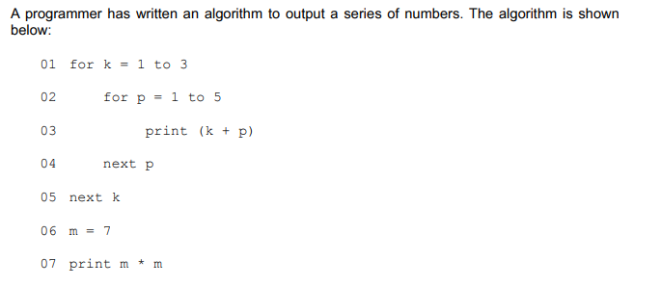

Q 26.1
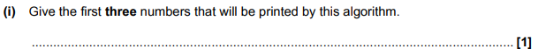
Q 26.2
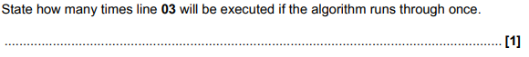
Q 26.3

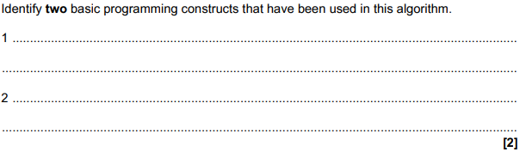
Q 26.4

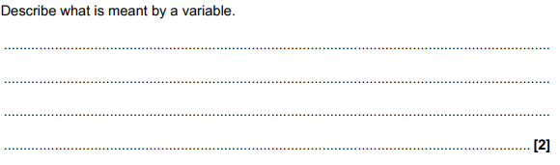
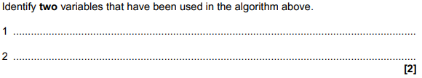
Q 26.5

Q 27

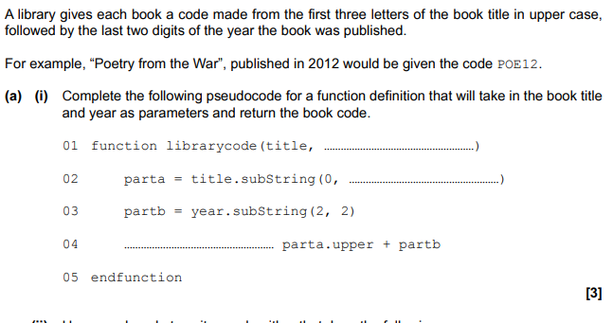
Q 27.1
